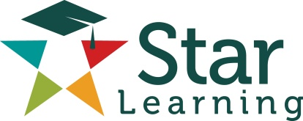

**Intro to Python – Syllabus**

**Description:**

The purpose of this course is showing how to program using Python Language. Throughout this 4-week course we will Python's built-in data types, Python's syntax, control structures, functions, modules, files, and more. During the course period we will complete so many hands-on exercises together and weekly challenges. After completing this introductory Python course, you will be ready to go to next step to learn deeper concepts in Python Programming and it's packages, such as; django for web development, pandas for Data science, Matplotlib for visualizing in complex dimensions, pygame for game development, scipy for scientific applications, numpy for huge numerical applications, and more.

**Instructor:** Enes Kemal Ergin

**Hours:** M-T-W-T-F:

**Course Outline:**

First Week (June 8th )

* Basic Syntax
* Variables and Numbers in Python
* Designing and Using Functions
* Strings in Detail
* Exercise Day 1

Second Week (June 15th )

* Decision Statements
* Modules and Methods
* Lists
* Repetition Statements
* Exercise Day 2
* Project Day 1

Third Week (June 22nd )

* Reading and Writing Files
* Built-in Data Structures (Dictionary-Tuples)
* Design of Algorithms
* Exercise Day 3

Fourth Week (June 29th)

* Review the concepts
* Exercise Day 4
* Project Day 2

**Materials:**

The worksheets of this class are provided every week including a classroom and homework classroom set.

This course does not require a textbook. We recommend Learning Python by O’Reilly media for those of you who want to have a reference book.